Objective of your work

The objective of this work is to develop an automated AI-based order-taking system capable of processing customer queries in real time. It aims to accurately interpret user input, extract order-related information, and retrieve data from the backend database.The goal is to improve operational efficiency, reduce manual workload, and ensure reliable, responsive order management.

This proposal originated from the growing need to improve efficiency in restaurant order management and reduce customer wait times during phone inquiries. Traditional IVR systems and manual call handling are often slow, costly, and unable to provide real-time, personalized responses.To address these challenges, an AI-driven automated order-taking system was proposed to streamline communication and enhance service quality.

methods
The system uses Twilio to stream incoming customer call audio to a Flask backend, where Deepgram converts the speech into text. This text is then processed using the OpenAI API to identify user intent and extract key order details. Based on this analysis, the backend queries a PostgreSQL database hosted on Google Cloud to retrieve accurate order information. The generated response is converted back to speech and returned to the caller. The materials used for implementing this system include Python, Flask, Twilio, Deepgram, OpenAI, PostgreSQL, Google Cloud, and a web-based frontend dashboard for real-time monitoring.

This project was developed using a Python-based Flask backend that serves as the central hub for processing customer calls. Twilio Programmable Voice was used to receive inbound calls and stream audio to the backend in real time. The audio was forwarded to Deepgram’s low-latency speech-to-text engine, which produced live transcriptions for further processing. These transcriptions were analyzed using OpenAI’s language model to identify customer intent and extract key details such as order numbers or customer names. Order information was securely stored in a PostgreSQL database hosted on Google Cloud SQL, and queries were executed using parameterized SQL through Flask. Once the relevant data was retrieved, the system generated a conversational response and converted it to speech using a text-to-speech engine before streaming it back to the caller through Twilio. A lightweight web-based frontend was built to display real-time transcripts and order details using REST and WebSocket updates. Development tools included Python, Flask, PostgreSQL, Twilio, Deepgram, OpenAI APIs, and GitHub for version control. Together, these materials and methods enabled a fully automated, low-latency voice assistant capable of understanding customer requests and delivering accurate order information in real time.

Block Diagram, Flowchart, Models, Results

The following section illustrates the complete workflow of the AI-based order-taking system. Each figure represents a key component—architecture, process flow, model implementation, and final output. These visuals help demonstrate how customer calls are processed from start to finish, combining telephony, speech processing, natural language understanding, and database retrieval.

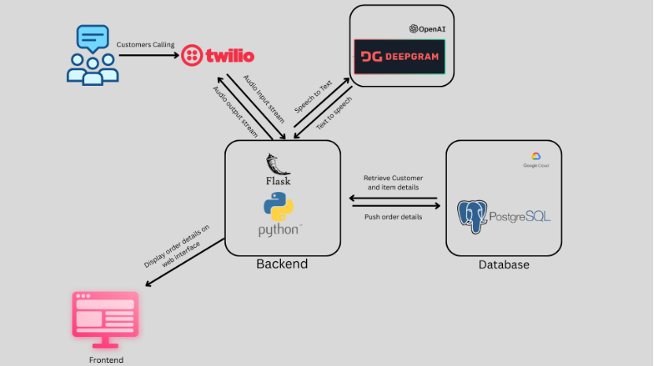

Fig.1. Proposed System Architecture

The system begins by receiving incoming calls through Twilio, which streams customer audio to the Flask backend. Deepgram converts the audio into text, and OpenAI analyzes the text to determine user intent. Based on this intent, the backend queries the PostgreSQL database hosted on Google Cloud to retrieve the customer’s order information. The backend then generates a response, converts it into speech, and streams it back to the caller. The process is also mirrored on the frontend dashboard for real-time monitoring.

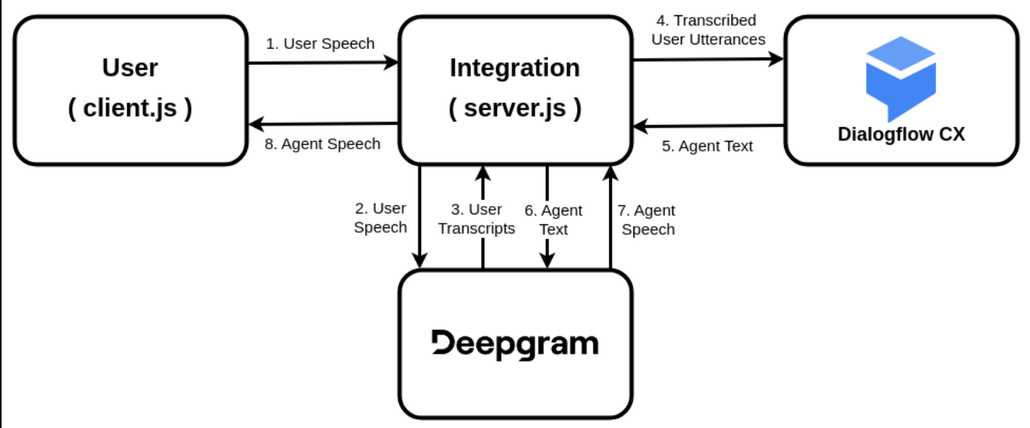

Fig.2. System Flowchart

The flowchart displays the step-by-step execution of the system. When a call begins, Twilio streams the audio to the backend. Deepgram processes the audio into text, which is then interpreted by the OpenAI model to extract intent and key details. The backend constructs and executes a database query to fetch order information. A text response is generated, sent to text-to-speech, and returned to the customer. The entire interaction is logged and displayed on the frontend interface.

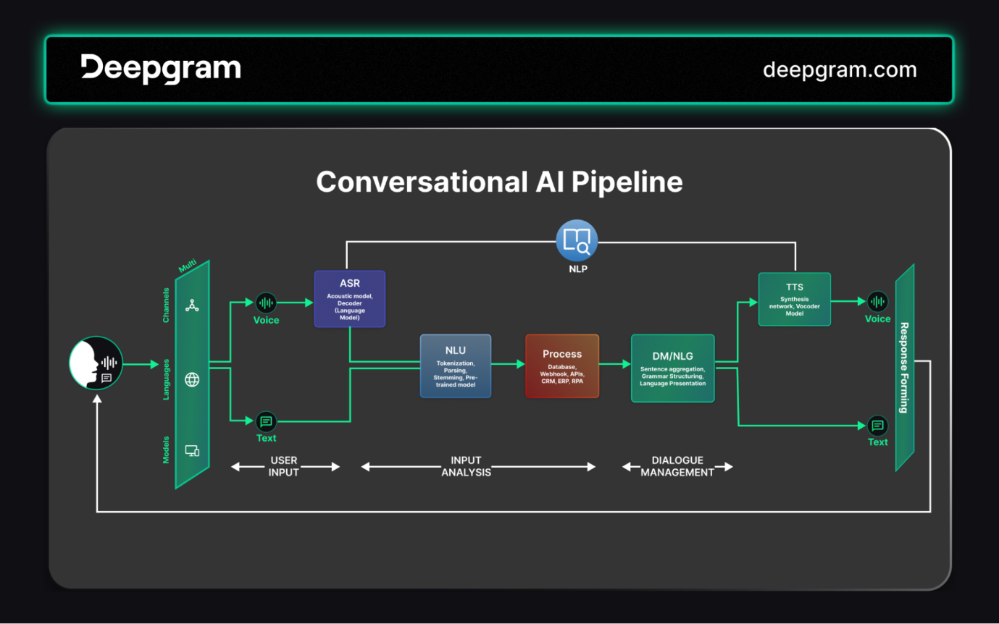

Fig.3. Implementation of Models

The model pipeline consists of Deepgram for speech recognition and OpenAI for natural language understanding. Deepgram produces real-time, high-accuracy transcripts from the customer's voice input. OpenAI then processes these transcripts to classify intent and extract essential entities such as customer name or order ID. These models work together to enable intelligent, context-aware responses rather than static menu-based interactions. The extracted information is passed to the backend logic for database retrieval.

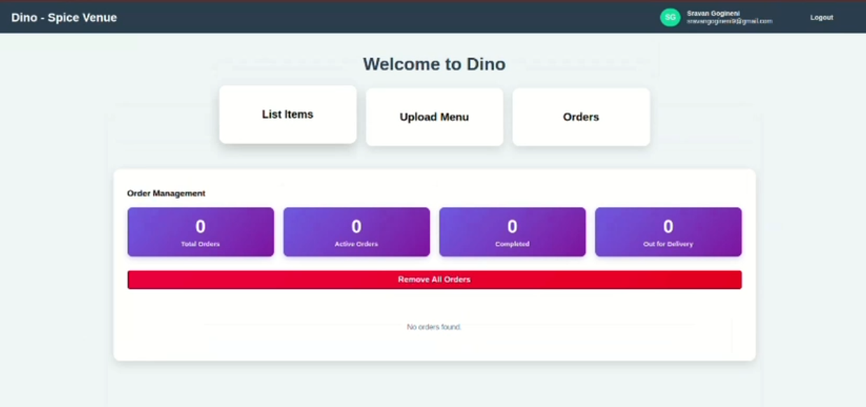

Fig 4
The output stage shows the final result of the system: a generated audio response delivered to the customer. After retrieving the order details, the backend formulates a clear text response and converts it to speech before streaming it back through Twilio. At the same time, the system updates the frontend dashboard with the recognized text, extracted parameters, and retrieved results, enabling supervisors to monitor interactions in real time.

col
The AI-driven order-taking system demonstrated that real-time speech recognition, natural language understanding, and database integration can effectively automate customer inquiries.The system consistently identified user intent and retrieved accurate order details with minimal delay. This automation reduces dependence on human agents while improving consistency and service quality.Real-time monitoring through the frontend dashboard further enhances transparency and system reliability.Future improvements may include multilingual support, enhanced error handling, and expanded conversational capabilities.

Li

The system’s performance depends heavily on internet connectivity and API availability, which may affect real-time accuracy during high traffic or outages. Speech-to-text accuracy can decrease in noisy environments or with strong accents, impacting intent extraction. The system cannot fully handle complex or ambiguous customer queries that require human judgment. Integration across multiple third-party services introduces potential points of failure and latency. Scalability may require additional optimization when handling a large volume of simultaneous calls.

Fu
Future development of the system can focus on incorporating multilingual support and accent adaptation to make the voice assistant accessible to a wider range of users. More advanced conversational models may be integrated to handle complex or multi-turn interactions, allowing the system to respond more intelligently to varied customer needs. Enhancing the assistant with sentiment analysis could help detect customer frustration and enable more empathetic responses. The platform may also be expanded to support full order placement, modifications, and cancellations, increasing its practical value for restaurants. Additionally, further optimization for large-scale deployment can improve performance, reduce latency, and strengthen overall system reliability.

References

Twilio. Programmable Voice API Documentation. Retrieved from https://www.twilio.com

Deepgram. Speech-to-Text API Documentation. Retrieved from https://developers.deepgram.com

OpenAI. Language Model API Documentation. Retrieved from https://platform.openai.com

PostgreSQL Global Development Group. PostgreSQL Documentation. Retrieved from https://www.postgresql.org/docs

Google Cloud. Cloud SQL for PostgreSQL Documentation. Retrieved from https://cloud.google.com/sql

Flask. Flask Web Framework Documentation. Retrieved from https://flask.palletsprojects.com

